**Week 4**

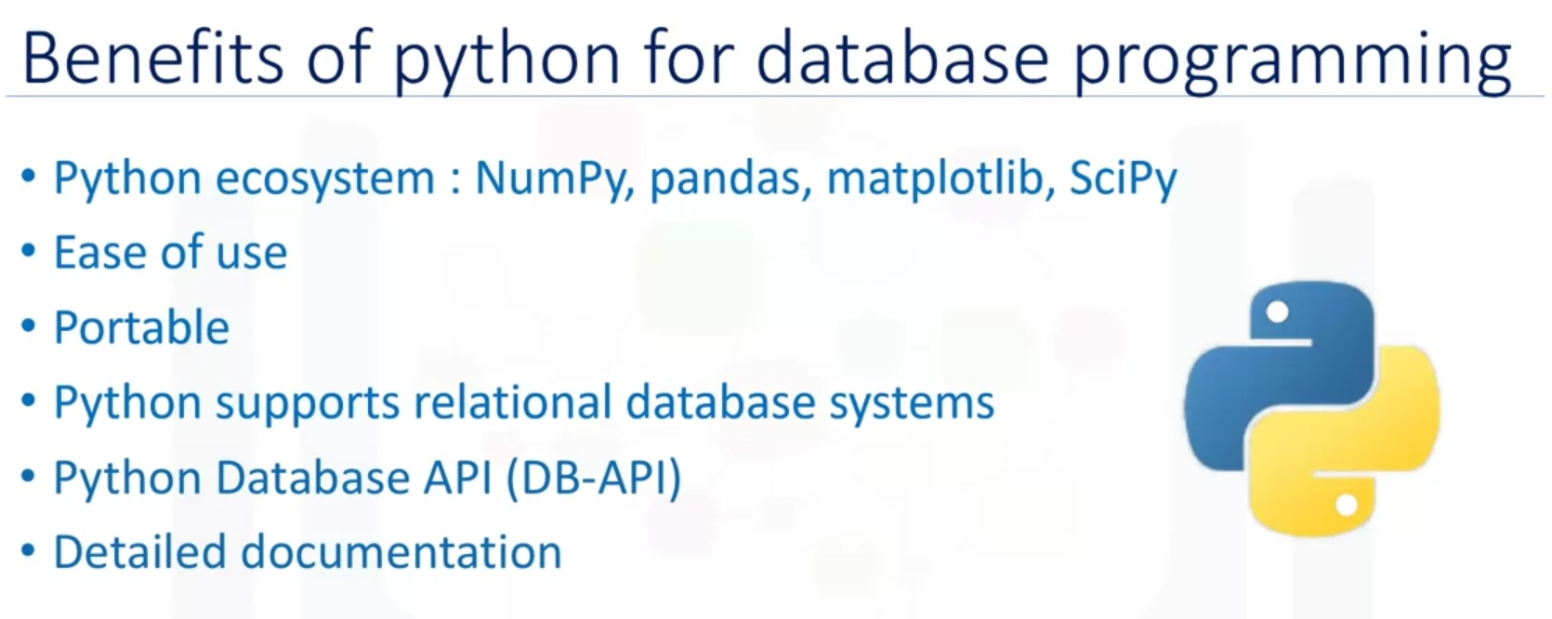

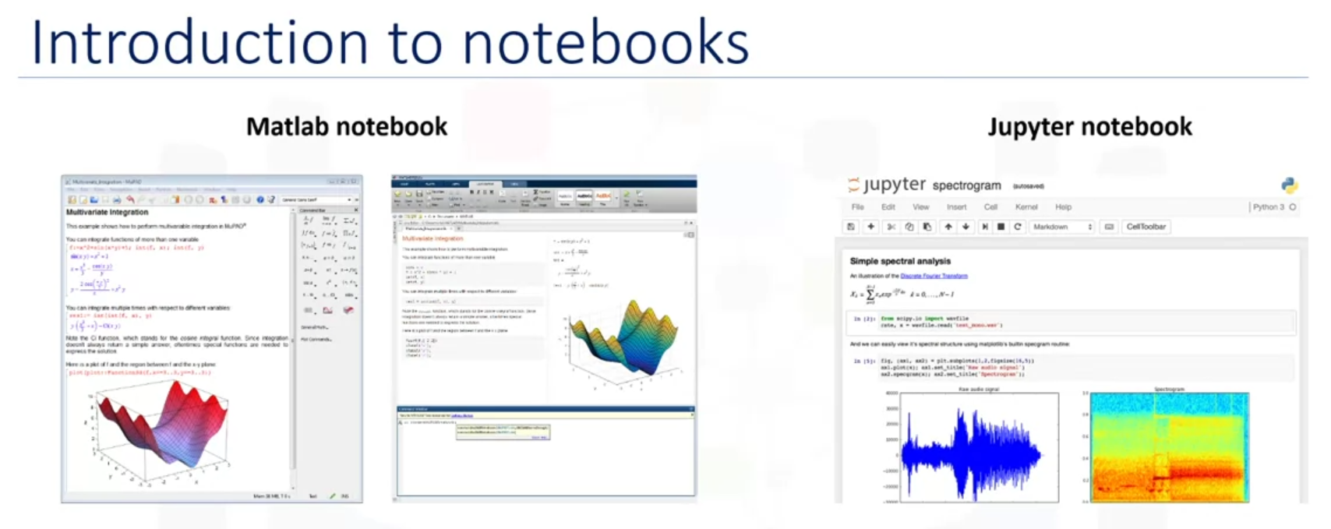

A notebook interface is a virtual notebook environment used for programming. Examples of notebook interfaces include:

* Mathematica notebook
* Maple worksheet
* Matlab notebook
* IPython Jupyter
* R Markdown
* Apache Zeppelin
* Apache Spark notebook
* Databricks cloud

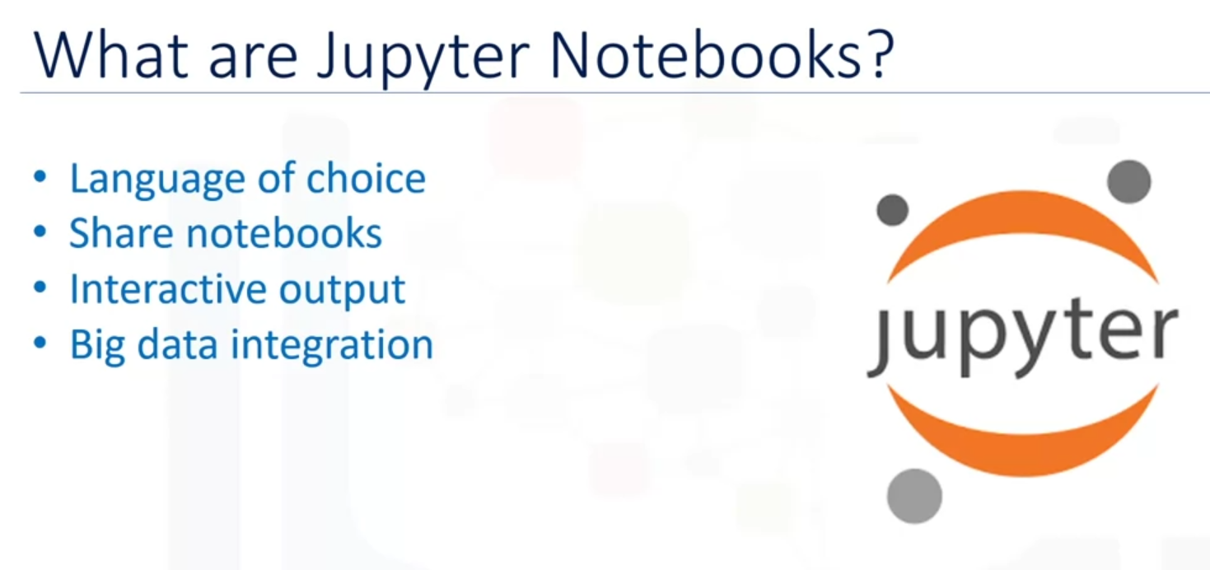

The Jupyter notebook is an open source web application that allows you to create and share documents that contain live code, equations, visualizations, and narrative texts.

Advantages of using Jupyter notebooks:

* Notebook support for over 40 programming languages including Python, R, Julia, and Scala.
* Notebooks can be shared with others by email, Dropbox, GitHub, and the Jupyter notebook viewer.
* Your code can produce rich interactive output HTML, images, videos, LaTex, and customized types.
* You can leverage big data tools such as Apache Spark from Python, R, and Scala, and explore that same data with pandas, scikit-learn, ggplot2, and TensorFlow.

